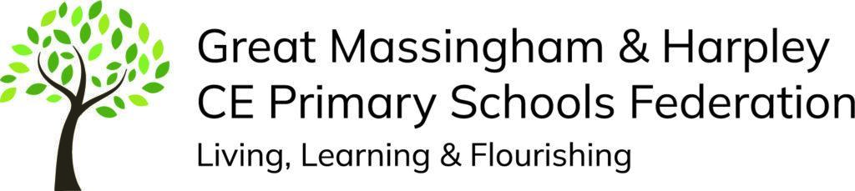

English curriculum statement
Our school vision
The Lord says, ‘I will instruct you in the way you should go; I will counsel you with my loving eye on you.’ Psalm 32:8
We live our vision with three dynamics at the heart: Living, Learning & Flourishing together.
We live as role models and advocate good choices
We learn in all we do with a loving eye upon us
We flourish in the way we go, within school and into the world beyond
Our five Core Values are: Kindness – Koinonia – Compassion – Responsibility – Forgiveness
Through a positive, caring environment, we provide the opportunity for every child to reach their full potential. We embrace Christian values and ensure all children are ready for their next steps. This statement sets out how we do this in the national curriculum subject of English.
INTENT
At Great Massingham and Harpley Primary Schools Federation, we know that communication and language skills, reading and writing form the basis of our children’s development. We understand that all other curriculum subjects depend on competence and fluency within these areas and therefore ensure we offer learning opportunities which enable children to access a broad and balanced curriculum. The English curriculum is driven by high expectations and incorporates our school vision and values.
We are determined to ensure that all children LIVE and thrive in their learning by being able to communicate and articulate clearly. In the EYFS, a huge priority is given to teaching children how to communicate with their peers and adults in order to meet their own needs and express themselves. We aim to encourage all our children to develop their literacy skills through creative and engaging lessons which will give them a range of opportunities to explore the English language in its many different forms.
We seek to foster, with all our children, a love of reading; to teach them the importance of reading to inform and a love of reading for pleasure; to show them the need for writing as a means of communication and a way to express themselves. In all lessons children will experience the same quality of teaching and learning opportunities so that all can achieve their potential. We aim to ensure all children LEARN to:
- Communicate in a variety of forms through speech, and writing.
- Read a wide range of materials thus broadening their knowledge and developing a love of literature.
- Use language and literacy skills and conventions accurately within all curricular areas.
We aim to give our pupils the chance to believe in their own ability to communicate and develop the power of resilience and perseverance to reach their full potential, striving to achieve their own personal learning goals and FLOURISH in the next stages of their learning.
Learning will build upon children’s knowledge and understanding from EYFS to Year 6 in line with the expectations of the Early Years Foundation Stage Statutory Framework and Primary National Curriculum.

IMPLEMENT
We implement our approach through high quality teaching delivering appropriately challenging work for all individuals. To ensure that Reading and spelling skills are taught coherently and progressively throughout the school we use “Twinkl Phonics” as our phonics scheme in EYFS and KS1. Showing fidelity to this scheme ensures early reading and writing requirements are met and quality provision is in place. If needed, children will continue to access this scheme if they have not met the expected standard by the end of KS1. Our EYFS curriculum also includes rich opportunities for children to develop their communication and language skills across all areas. Story/rhyme time are key to this and encouraged not just in EYFS but throughout the school. In KS2 children are taught spellings using the national curriculum guidelines. Classrooms have a range of different resources to support children including sound mats, dictionaries, word books, posters and children are taught specific strategies to support them with spelling (chunking syllables, sound segmenting, learning spelling rules). Handwriting is taught alongside the teaching of phonics and spellings and children are taught to form and join letters accurately.

Teachers plan to develop reading comprehension and creative writing skills using the “Literacy Tree” scheme which covers all of the National Curriculum content for Y1 – Y6 and the Early Learning Goals for EYFS. The scheme ensures that reading and writing skills are developed through the use of high quality texts by significant authors. The provision ensures that skills are built upon previous knowledge and that children can experience and learn the formal conventions of reading and grammar in a creative way. Lessons address the needs of all pupils including those with SEND with the use of scaffolding, skilful questioning and carefully designed activities. We use an ‘I do; We do; You do’ approach to ensure children have the learning modelled and are given opportunities to practise their skills within groups, pairs and also independently.

In addition to phonics/spellings, reading and writing lessons, children are given regular opportunities to read for pleasure and to listen to a variety of texts being read by an adult. This helps to give literacy a context and develop an appreciation and love of quality literature.

The vast majority of our pupils will progress through the programmes of study at broadly the same pace. Pupils who grasp concepts rapidly are challenged by being offered opportunities to broaden the range of literature they read and write. For those who are less secure, teachers aim to rapidly address gaps in children’s understanding within the lesson and through targeted intervention outside of the lesson.

IMPACT
Through formative and summative assessment, we continuously monitor pupils’ progress against expected attainment for their age and identify gaps in their learning. Teachers use these to inform their planning to ensure that all pupils have a secure understanding and that they are all challenged at an appropriate level.

We will know our English Curriculum is having the desired impact on our children when:

- They can talk enthusiastically about their learning in all areas demonstrating oracy and communication skills.
- They can explain key vocabulary and use it appropriately in lessons.
- They demonstrate an ability to apply phonic/spelling skills in order to read and write showing progress over time.
- They can talk enthusiastically about the books they have read explaining the key themes or information.
- They use the skills they have learned within English lessons to demonstrate understanding within other curriculum areas.
- They show a love of literature (reading for pleasure or enjoying having books read to them).
- They can express themselves coherently and creatively through their written work.

